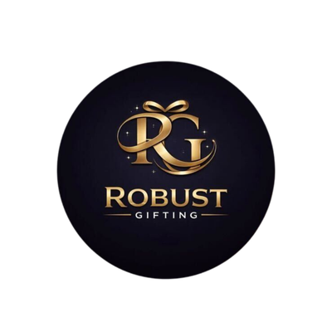
ROBUST GIFTING

Cardholder
Catalogue
Leatherette · Metal · Cork · Checkered
Thoughtful gifting. Built to impress.
CURATED COLLECTION • VOLUME 04 • 2026

The Cardholder Collection
20 cardholder models — a complete corporate range.
From classic leatherette models with silver or gold clips to slim metal, eco cork and checkered-pattern finishes — this catalogue brings the full Robust Gifting cardholder range into one place. Every model is offered in multiple colour variants, listed under each card. Prices shown are exclusive of 18% GST.
All items available in bulk. Custom branding, logo embossing and packaging on request.
ITEM NO. 01  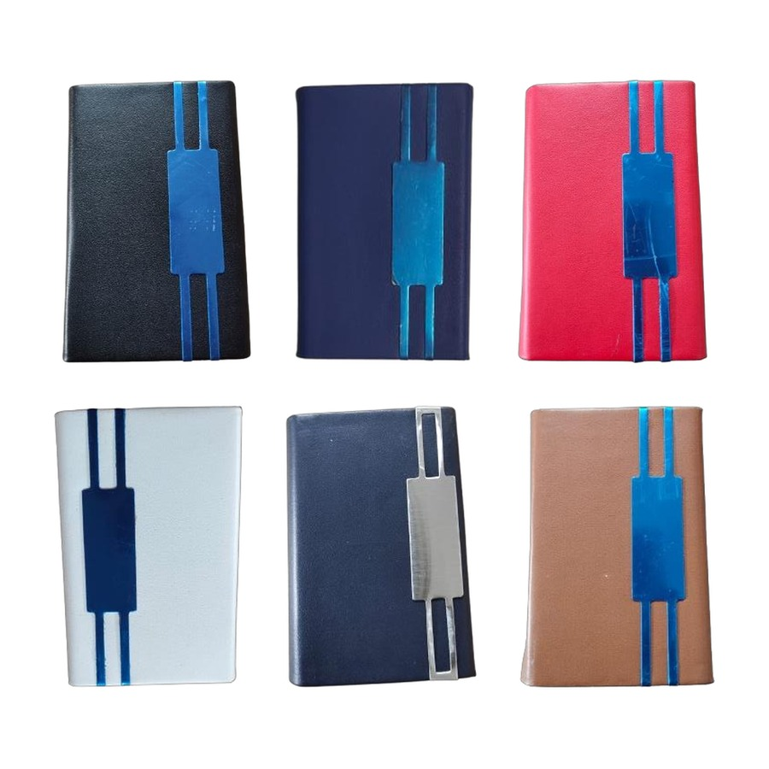  No-18 Silver Clip  Leatherette cardholder with centre silver clip.  Colours: Black · Blue · Red · White · Navy Blue · Tan  ₹ 55 each + 18% GST |  | ITEM NO. 02  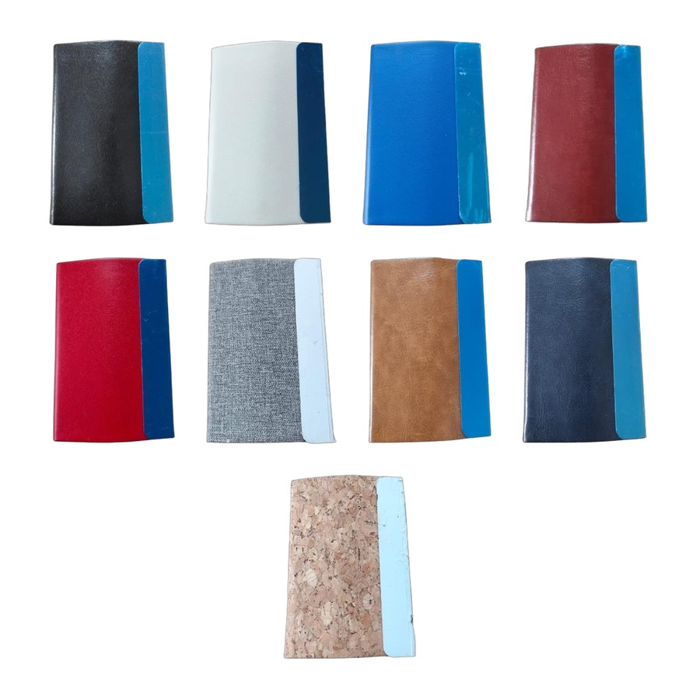  No-11 Silver Clip  Leatherette cardholder with side silver clip.  Colours: Black · White · Blue · Maroon · Red · Grey · Tan · Navy Blue · Cork  ₹ 55 each + 18% GST
ITEM NO. 03  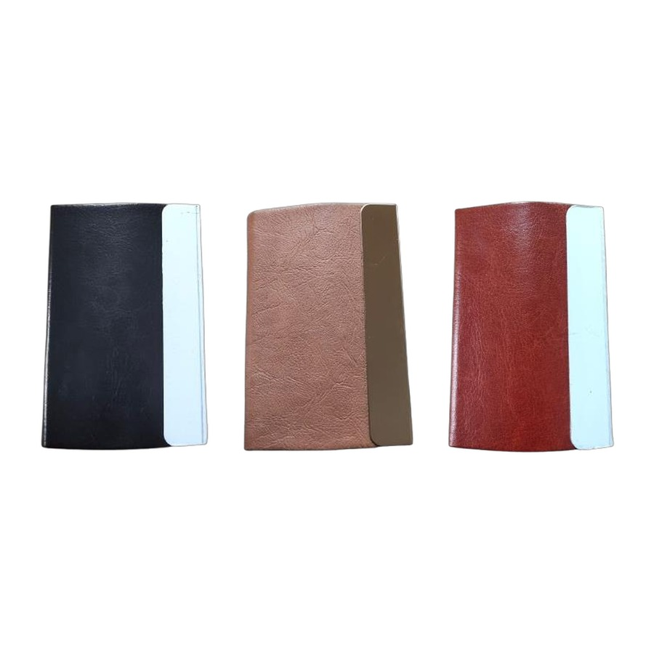  No-11 Gold Clip  Leatherette cardholder with side gold clip.  Colours: Black · Tan · Maroon  ₹ 60 each + 18% GST |  | ITEM NO. 04  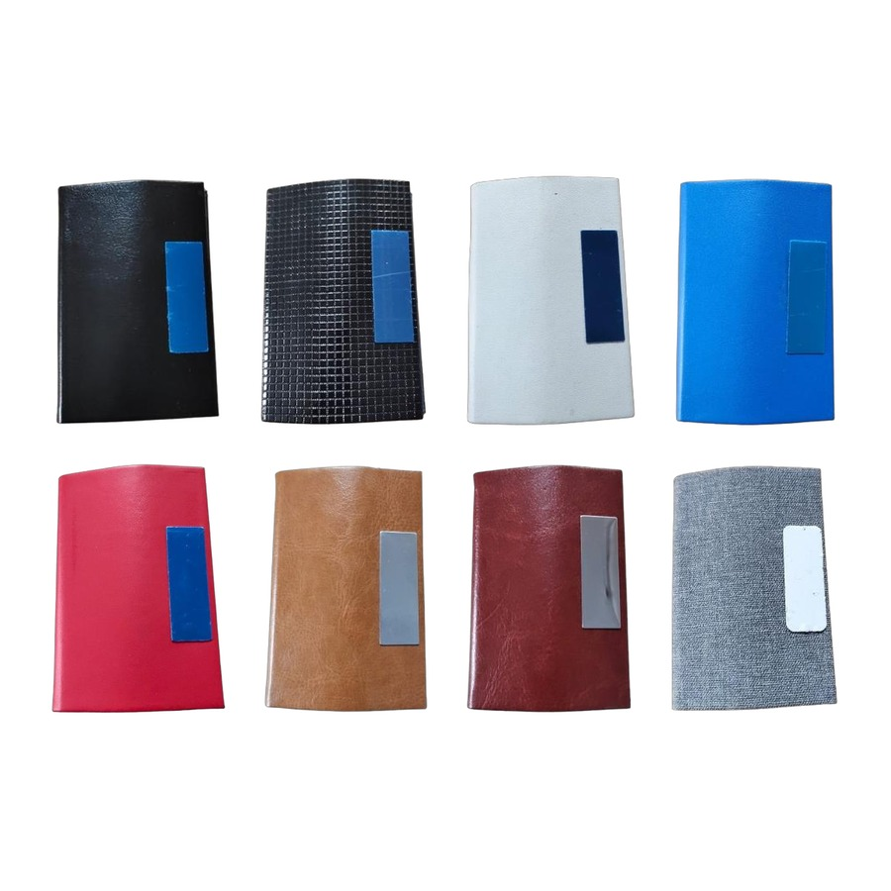  No-10 Silver Clip  Compact cardholder with silver clip detail.  Colours: Black · Black Textured · White · Blue · Red · Tan · Maroon · Grey  ₹ 50 each + 18% GST
ITEM NO. 05  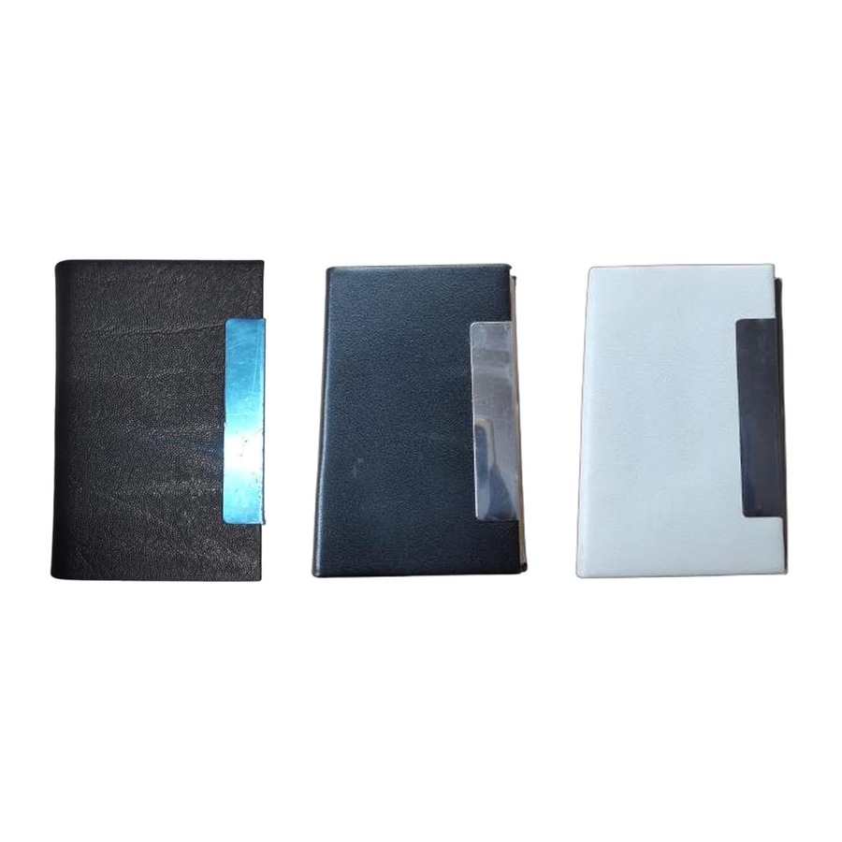  No-24 Silver Clip  Slim-line cardholder with silver clip.  Colours: Black · Black · White  ₹ 60 each + 18% GST |  | ITEM NO. 06  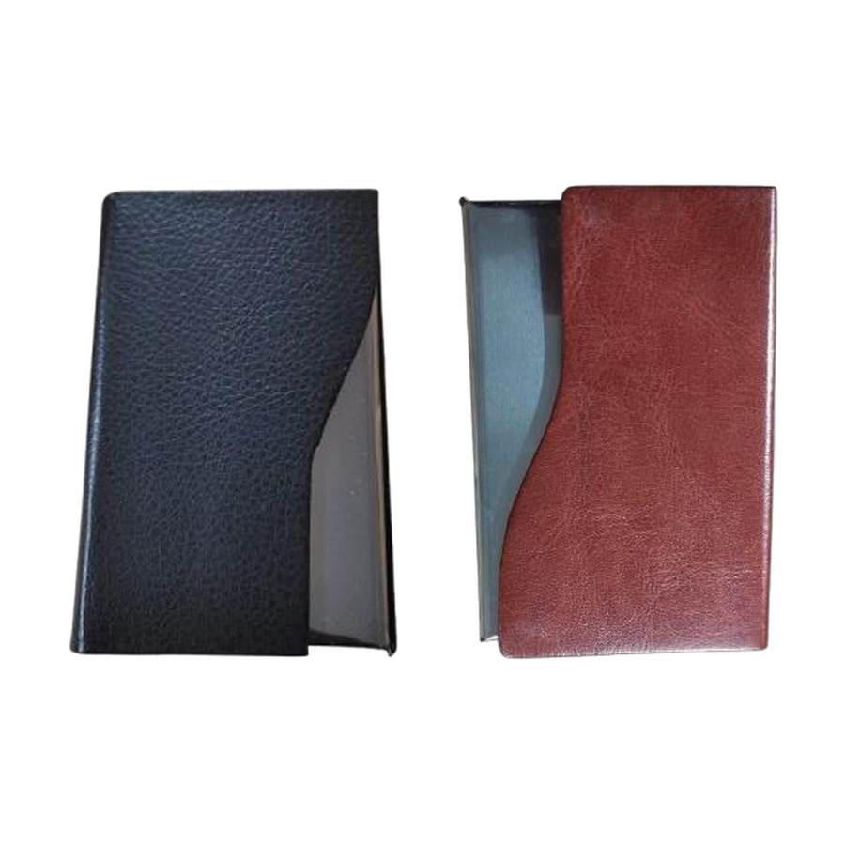  No-28 Silver Clip  Bi-fold style cardholder with silver clip.  Colours: Black · Maroon  ₹ 60 each + 18% GST
ITEM NO. 07  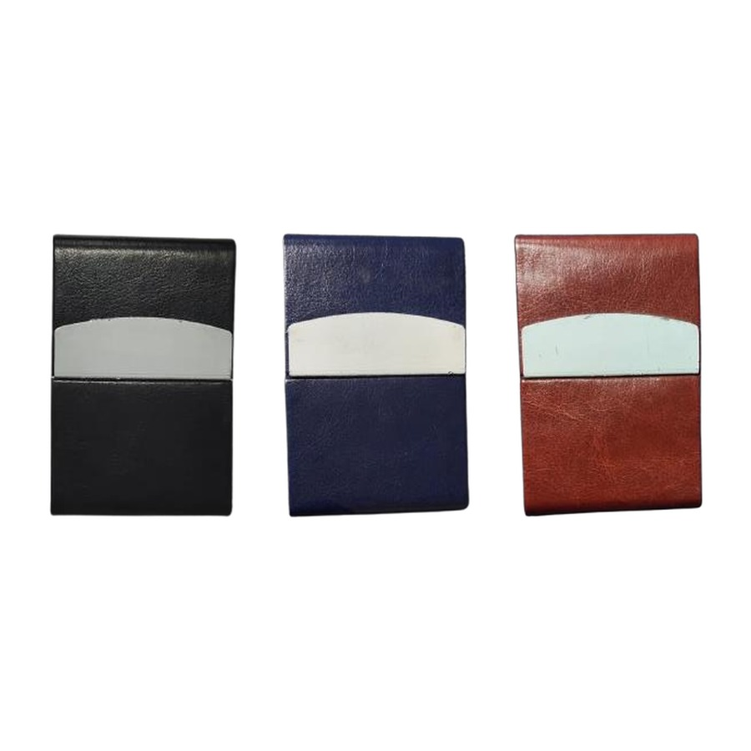  Classic Magnetic Cardholder  Magnetic-close cardholder with metal accent.  Colours: Black · Blue · Maroon  ₹ 60 each + 18% GST |  | ITEM NO. 08  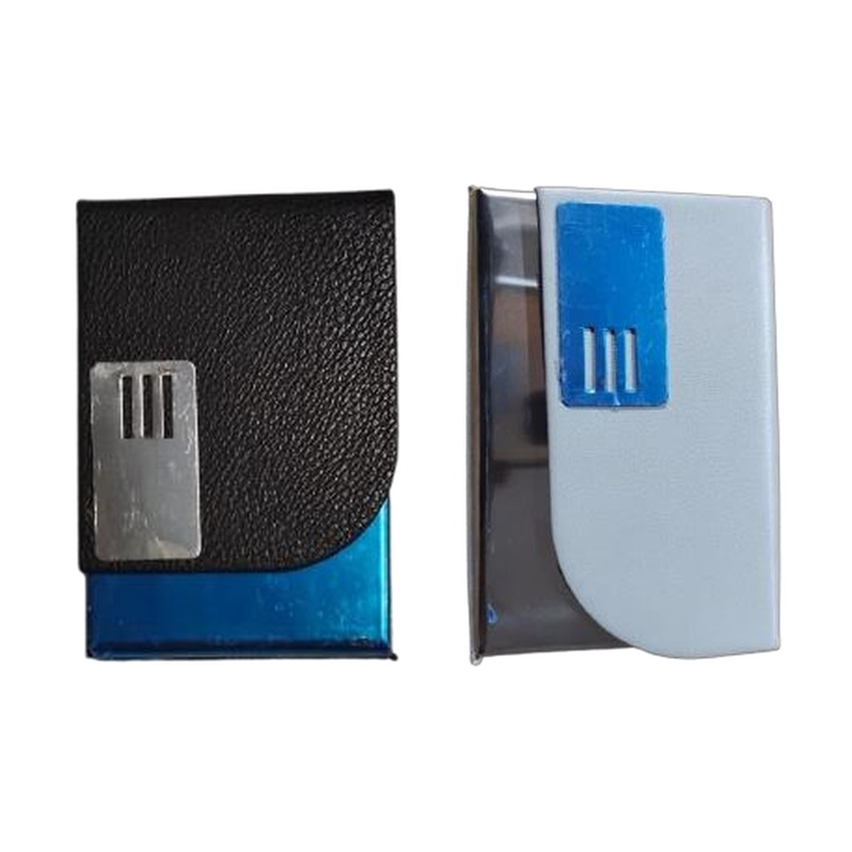  Clip-Lock Cardholder  Leatherette cardholder with front metal clip.  Colours: Black · Grey  ₹ 60 each + 18% GST
ITEM NO. 09  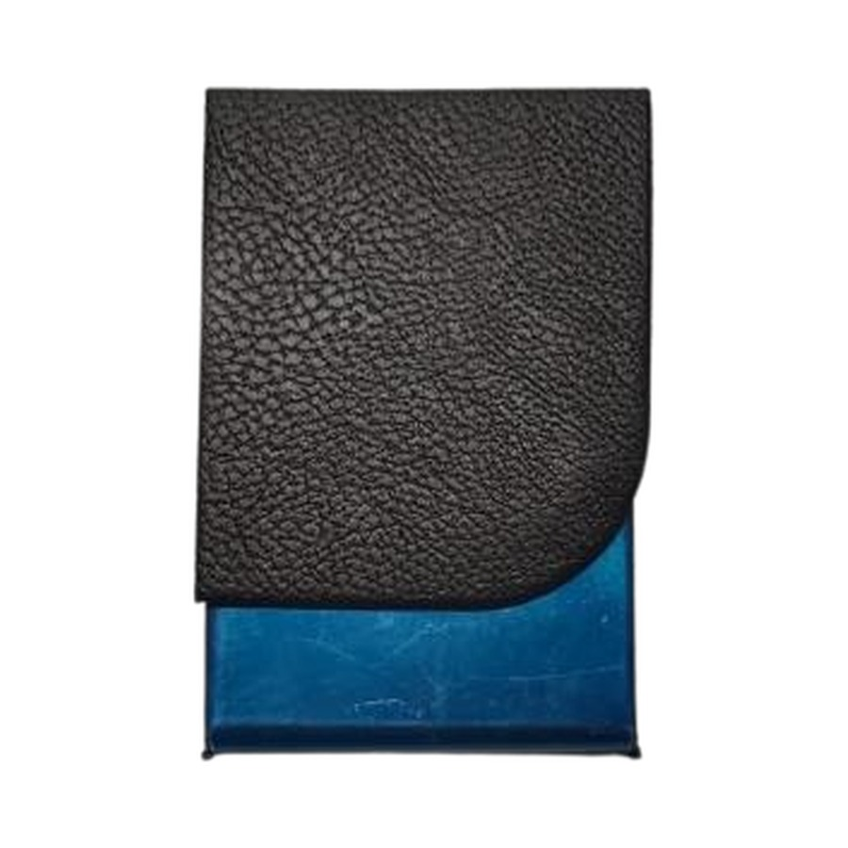  Magnetic Flap — Silver Clip  Magnetic flap cardholder with silver clip.  Colours: Black  ₹ 60 + 18% GST |  | ITEM NO. 10  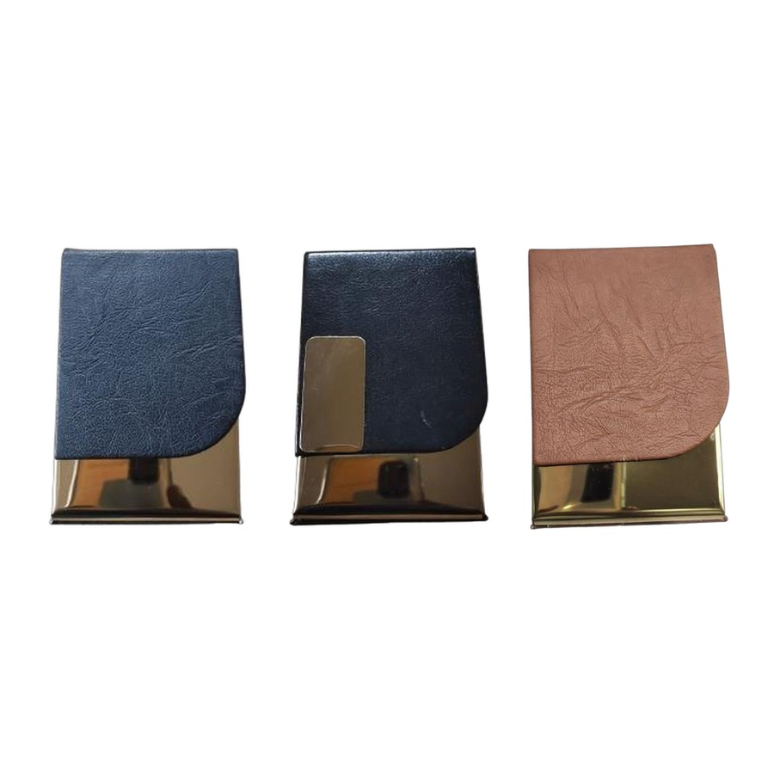  Magnetic Flap — Gold Clip  Magnetic flap cardholder with gold clip and base trim.  Colours: Navy · Black · Tan  ₹ 90 each + 18% GST
ITEM NO. 11  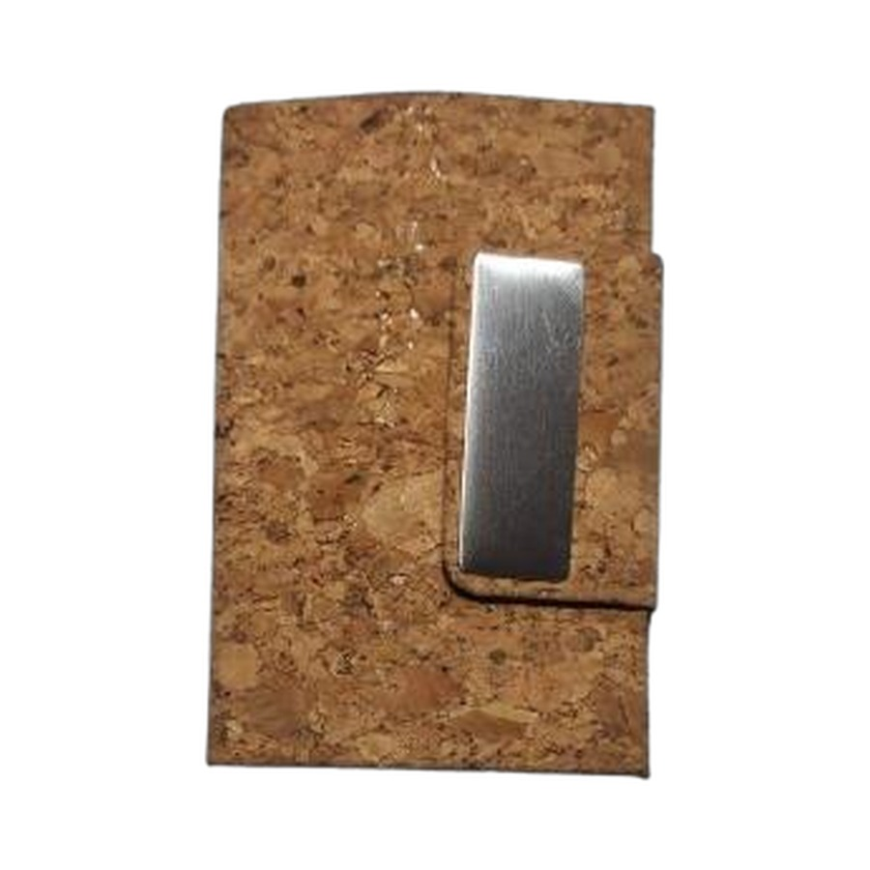  Cork Cardholder with Clip  Eco cork finish with silver clip.  Colours: Cork Natural  ₹ 65 + 18% GST |  | ITEM NO. 12  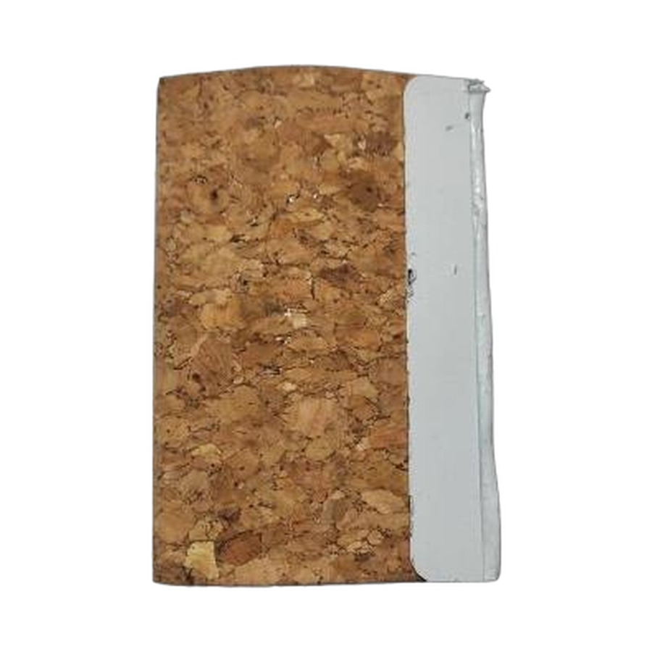  Cork Cardholder Sleeve  Eco cork finish slim sleeve.  Colours: Cork Natural  ₹ 55 + 18% GST
ITEM NO. 13  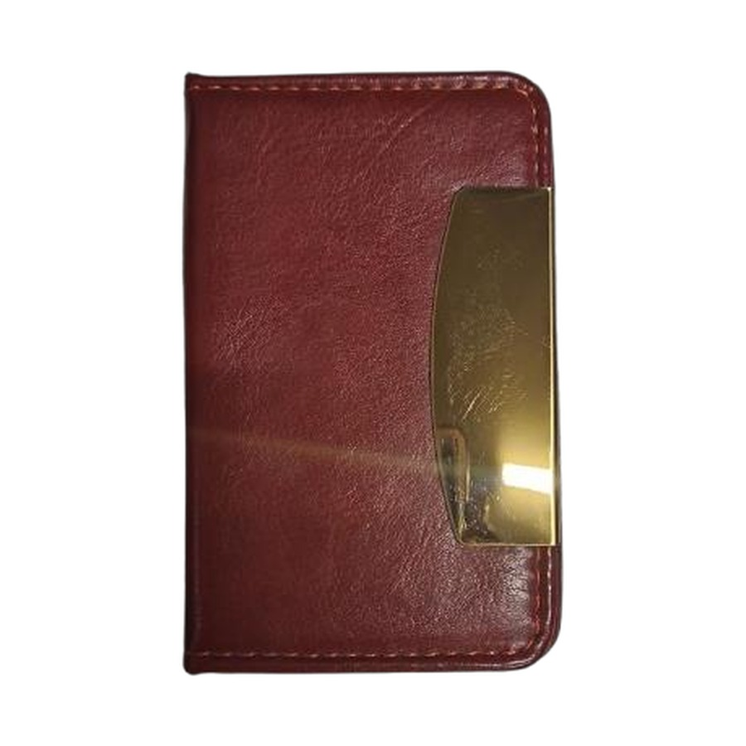  Executive Gold-Clip Cardholder  Premium leatherette cardholder with gold clip.  Colours: Maroon  ₹ 90 + 18% GST |  | ITEM NO. 14  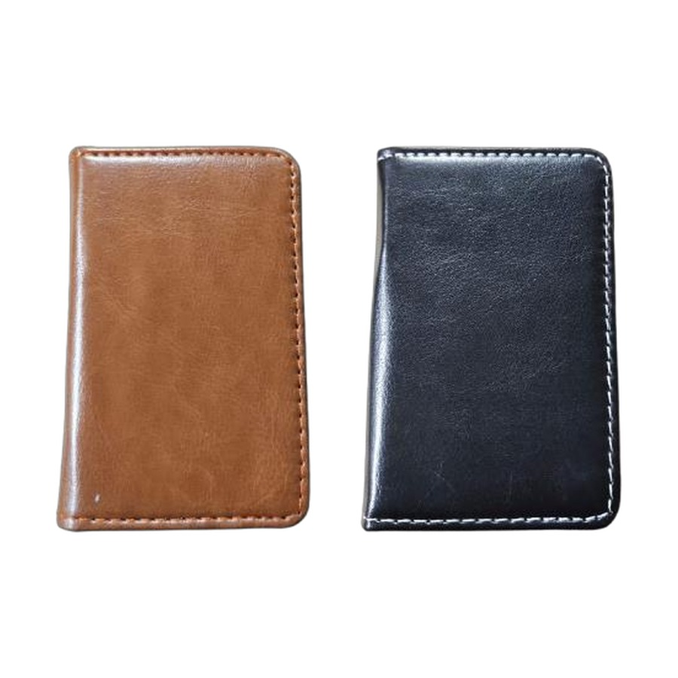  Slim Leather Cardholder  Stitched leather-finish slim cardholder.  Colours: Tan · Black  ₹ 75 each + 18% GST
ITEM NO. 15  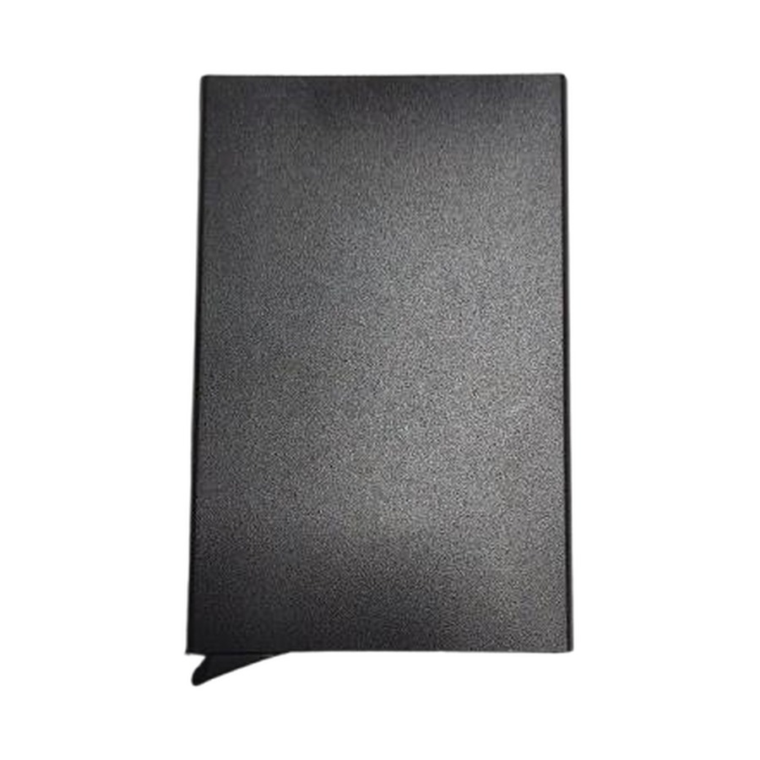  Premium Matte Metal Cardholder  Matte-finish metal cardholder.  Colours: Black  ₹ 75 + 18% GST |  | ITEM NO. 16  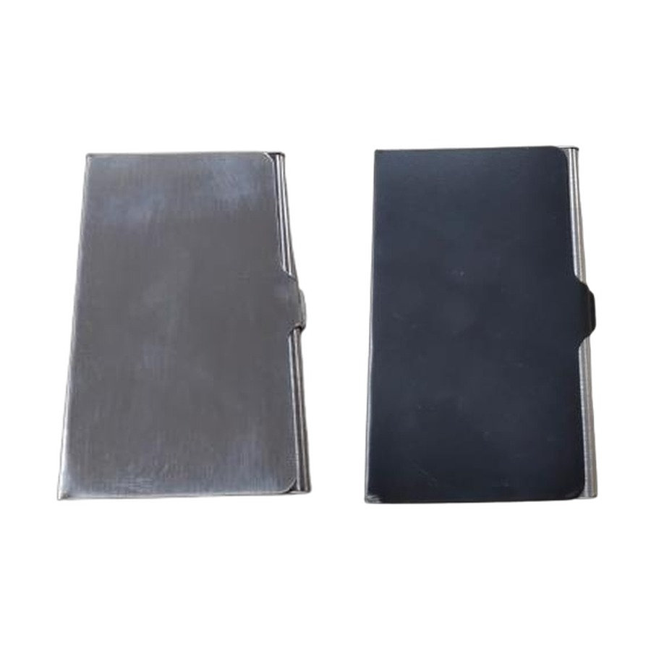  Metal Cardholder  Classic metal cardholder with snap close.  Colours: Silver · Black  ₹ 35 each + 18% GST
ITEM NO. 17  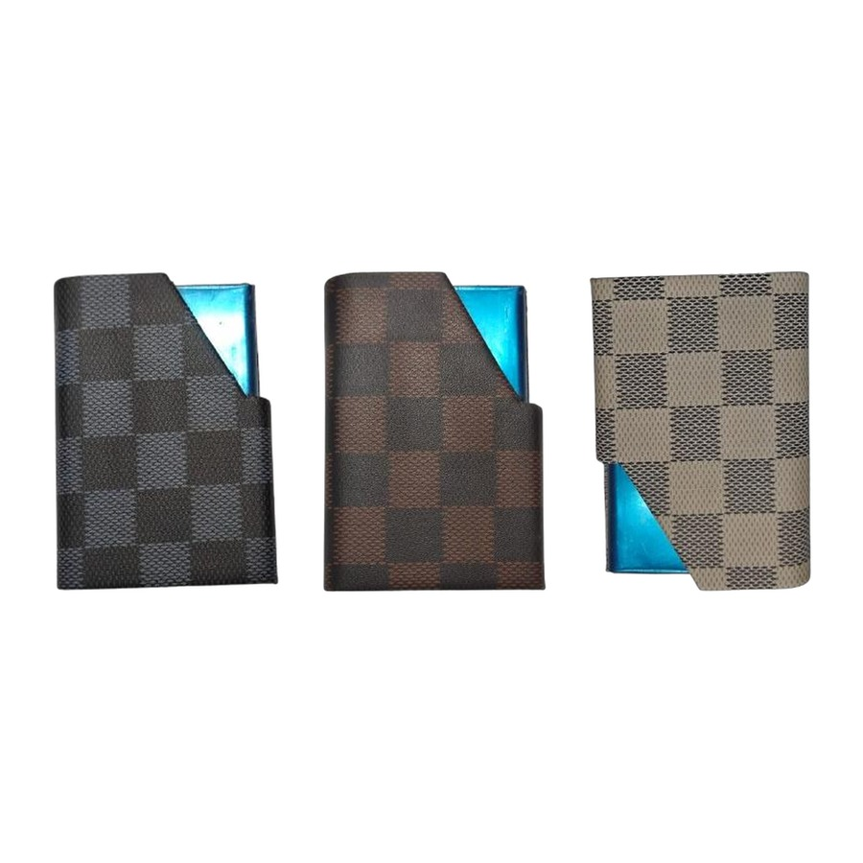  Checkered Pattern Cardholder  Checkered-pattern cardholder with blue accent.  Colours: Blue · Maroon · White  ₹ 65 each + 18% GST |  | ITEM NO. 18  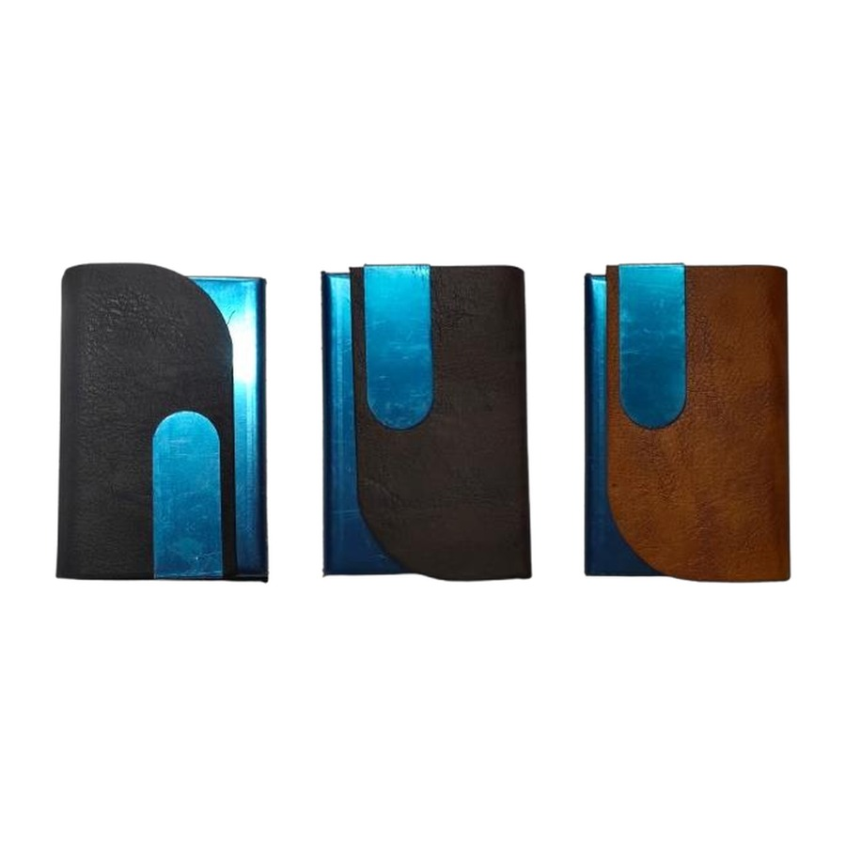  Curved Flap Cardholder  Curved-flap leatherette cardholder with blue accent.  Colours: Black · Maroon · Tan  ₹ 65 each + 18% GST
ITEM NO. 19  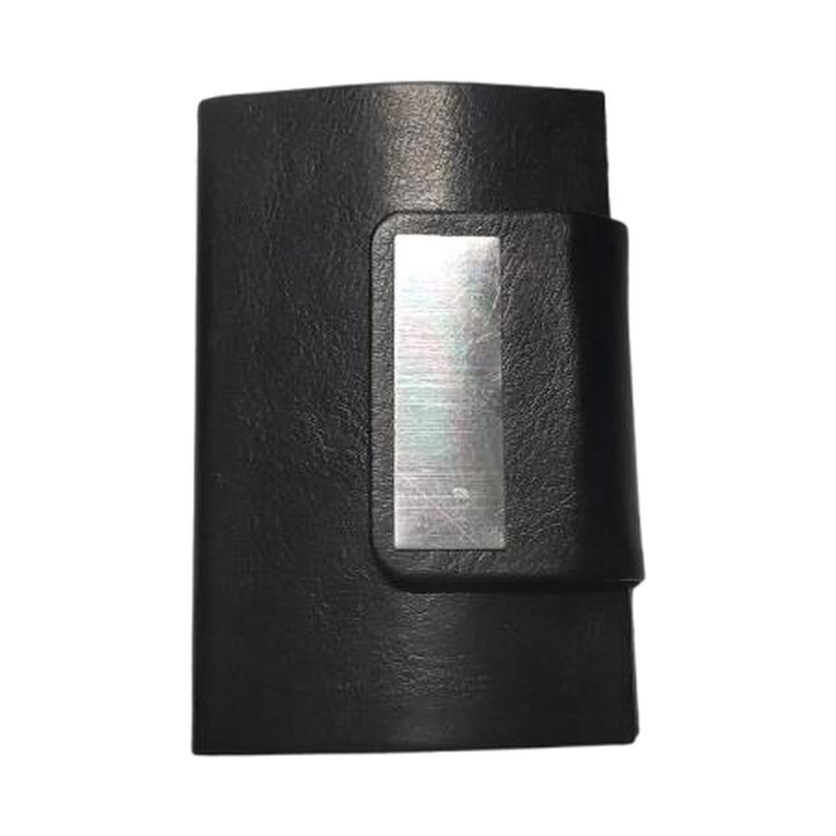  Slim Clip Cardholder  Slim leatherette cardholder with metal clip.  Colours: Black  ₹ 65 + 18% GST |  | ITEM NO. 20  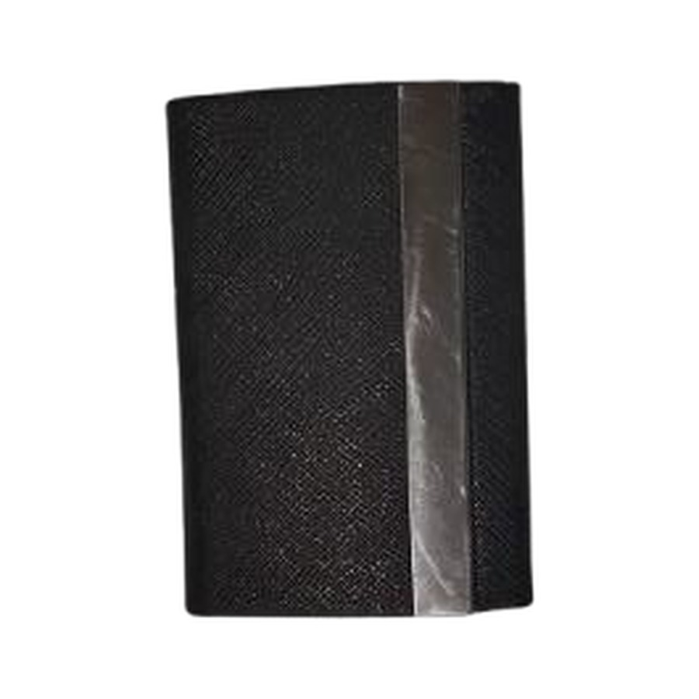  Two-Way Cardholder  Two-way opening cardholder with textured finish.  Colours: Black  ₹ 90 + 18% GST
Thank you
for considering Robust Gifting

All items available for custom branding.
Minimum order quantities and lead times on request.
Prices are exclusive of 18% GST. Valid 2026.

